**Nuski**Ahamed

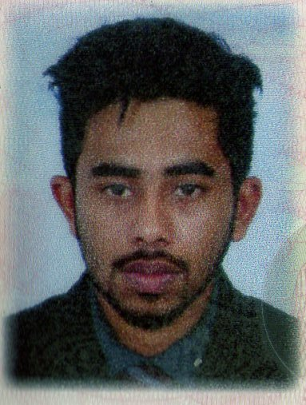

**Full name -** Mohamed Thahir Nuski Ahamed

**Address -** No: 263/c Maberiya,Ukuwela,Sri Lanka

**Age -** 21 years

**Gender -** Male

**Nationality -** SriLanka

**Birth day:**31/03/1994

**Email:** Nuski101@gmail.com

**Mobile:** +94758357508 / +94771256797



**Career Objective:**

To succeed in an environment of growth and excellence and earn a job which provides me job Satisfaction and self-development and help me achieve personal as well as organization goals



**Professional Qualifications:**

* BTEC HND in Network and Security - Edexcel - UK (2013 September –2015 January In British College of Applied Study).
* Certified as a Computer Hardware Professional.
* Certified in Windows Network Administration.
* Certified in Linux Operating System.
* Certified in Cisco router configuration.

**Education Qualifications:**

* G.C.E O/L Examination – 2010. (Ajmeer National School. Ukuwela )



**Work Experience :**

* + - * Worked as Trainee Network Administrator in SK International Holdings (thalawathugoda road, madiwela, kotte.Colombo. SriLanka)

**Professional Experience:**

* Leadership Training Camp after O/L Exam.
* School Sport House Captain.

**Extracurricular activities:**

* School Old Boys Member
* School Cricket Captain
* School Muslim Majilish Member



**Language Skills:**

* Fluent in speaking, reading and writing English
* Fluent in speaking, reading and writing Sinhala
* Fluent in speaking, reading and writing Tamil



**Professional Skills:**

* Computer Assembling, Upgrading and Servicing/ Troubleshooting and Repairing
* Operating System Installing and Configuring (Windows 98,2000, XP,2003, Vista,2008, Win7, win8 and windows 10 )
* Installing and Configuring Application Software, Virus Guards, Drivers
* Introduction to Networks (LAN / WAN)
* IP Addressing (IP V4 & V6)
* Local Area (LAN) and Wide Area Network (WAN) Concepts
* Implementation and Planning Network Infrastructure
* Switch and Patch Panel Installation
* Installing and Configuring Windows Server 2008 and 2012 and Windows Vista, 7 & 8
* Implementing Workgroup and Single Domain Environment
* Managing Windows 2003,2008 & 2012 Domain Environments
* Microsoft Windows Server administrative Tasks
* Installing & Configuring DNS , DHCP Server ,Active Directory Service , File Servers & Printer Servers, Internet Information Service(IIS) web, Mail Servers(Exchange Server 2013-2016)
* Active Directory Reinstallation
* Installing a Remote Installation Server (RIS)
* Maintaining and Troubleshooting Windows 2003 2008 and 2012 Servers
* ADSL Router Configuration
* Installing & Configuring Proxy Servers
* Wireless (Wi-Fi) Router Configuration
* Wireless Networking With Windows 2003, 2008 2012 Serves
* Implementing Latest Wired and Wireless Technologies



**Extra Skills:**

* Multimedia design
* Web designing
* Cisco router configure
* Blogging and wordpress



**References:**

**SK International Holdings**

**Mr. K.Niluksha**

**320/3/1 ThalawathugodaRoad, Madiwela, Kotte**

**Email- info@skinternational.info**

**Phone 0777274552**

I declare that the above particulars that I have given to you are true and correct to best of my knowledge. I would be pleased to give you any further information if required.

I believe my qualification will enable me to successfully assume the responsibilities of the post at your organization.

Date Signature

………………. …. …………………………..